

**Assignment-2: Report for E-Commerce Website.**

Student Name: Prakash Baskaran

Student ID: 21802557

Lecturer Name: Noor Al-Ani

Table of Contents

1. Introduction 2

2. Scope 2

3. Features and layout of the site 2

4. Conclusion 8

# 1. Introduction

In the report, an e-commerce website is developed for a PC Builder (client). PC Builders is computer hardware store which sells all the components required to build custom workstations.

The website is developed using ASP.net MVC Core, the database is SQL server and code first entity framework is used to build the database. The website is designed using Bootstrap and Cascading Style sheet CSS templates from template.io. The users of the site can create account to buy the products.

In this report, the scope, stakeholder analysis and screenshot of the e-commerce website along with its requirements and functionalities are explored.

# 2. Scope

The main scope is to develop an e-commerce website for the client PC Builders. In addition, the following are the parameters which are in scope:

* Create an attractive layout as per client’s demand.
* All the products can be added and modified from the database.
* Create a register and login page.
* Adding pictures of products along with the description, cost and title to database.
* Creating a shopping cart with list all purchased products along with total sum.
* Add customer review in home and about us page.
* Creating a mobile-compatible site.

Following are out of scope:

* The success of business using this website.
* Failure of the site due to poor hosting services/ servers.
* Adding additional features to an existing site for free.
* Improper store location on Google Maps.
* Loss or corruption of data due to damage to servers.
* No guarantee if the source code is altered

# 3. Features and layout of the site

In the section, the features and the layout of the website are shown.

The users are welcomed with the home page as shown in the figure below from which the user can register/ signup or sign in to view products.

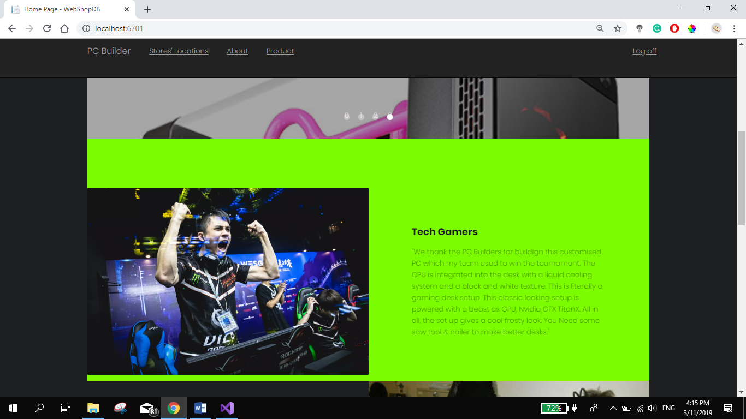

Fig.1. Home screen with navigations option in the navigation bar.

New customers can register/ sign up as shown below.

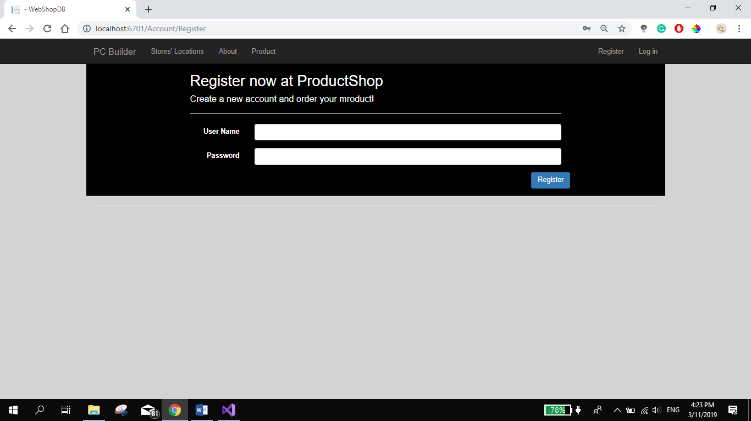

Fig.2. Register/ sign up page.

Once the user has signed up, they can use the credentials to sign in as shown in the below figure.

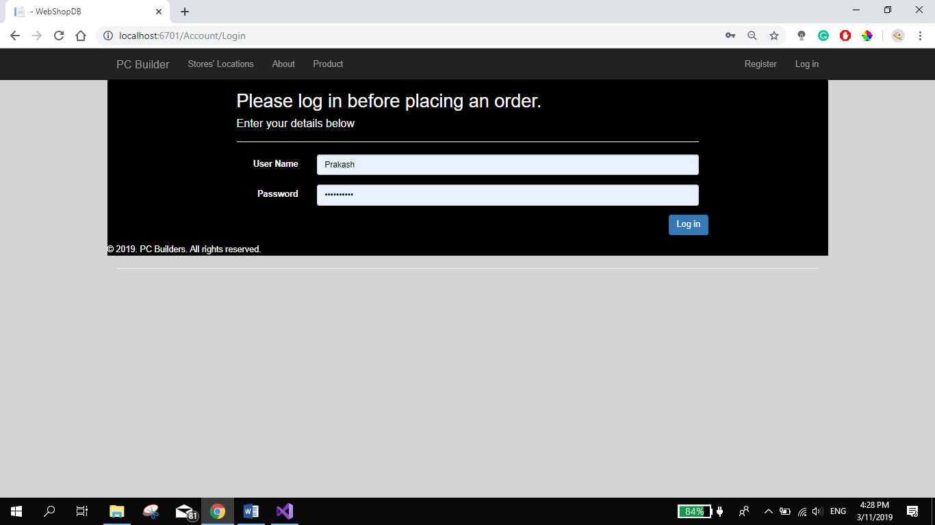

Fig.3. The sign-in page for the customers to sign in.

The users can view different physical locations of the store which is linked with Google Maps.

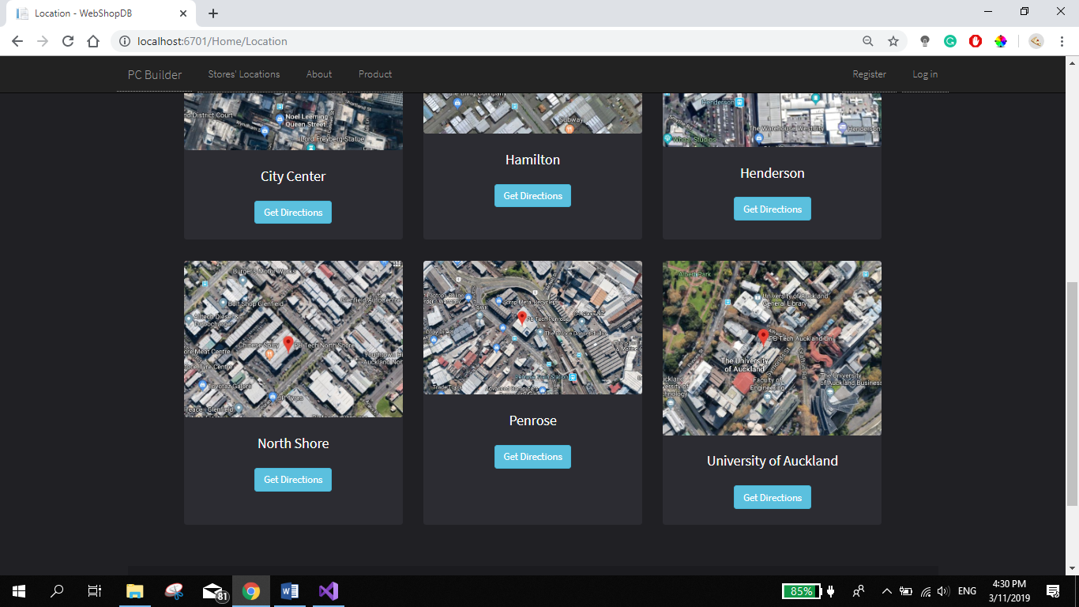

Fig. 4. Store locations page.

Once clicked the Google Map page opens in the new tab with the intended destination.

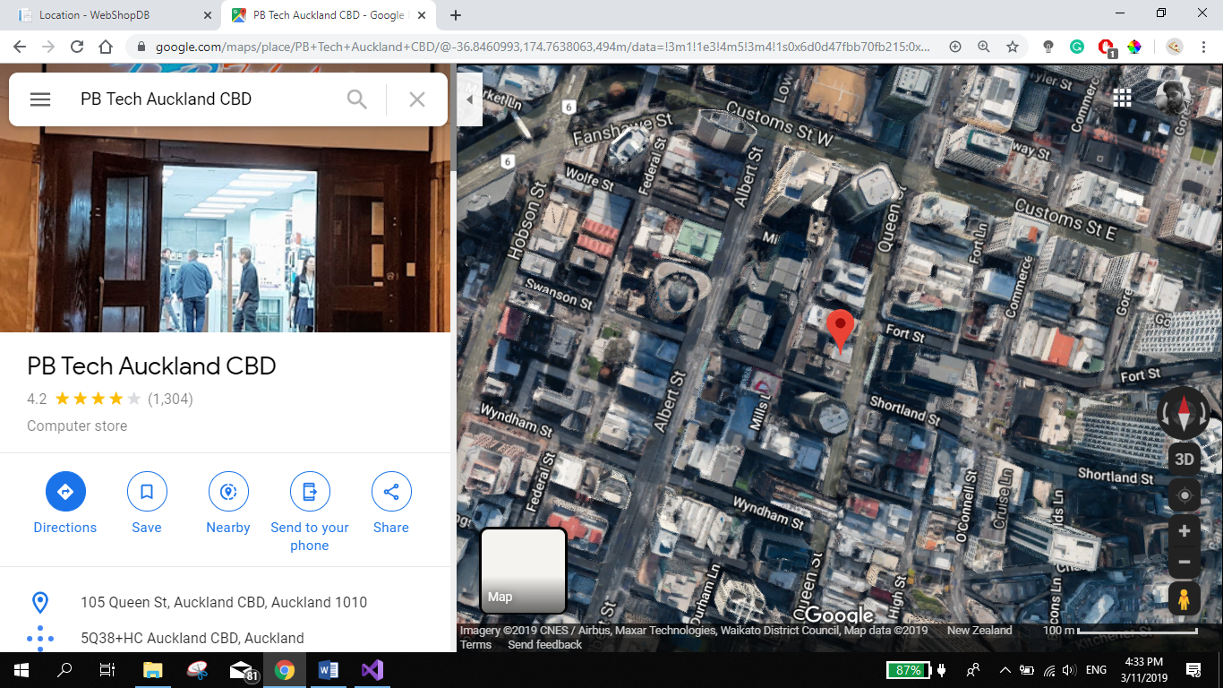

Fig. 5. Store location and direction on Google Maps (this store is given as an example).

The figure below shows the about us page with the PC Builder achievements and what they do along with the

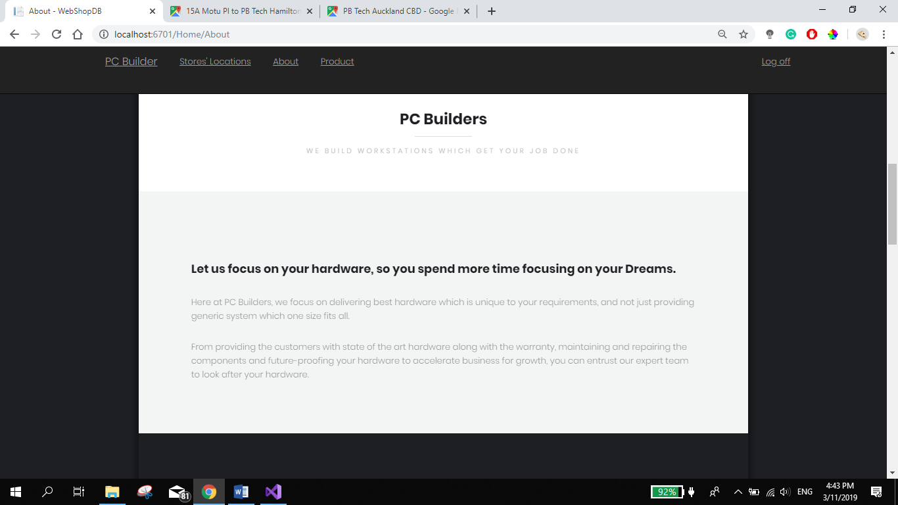

Fig.6. About us page 1.

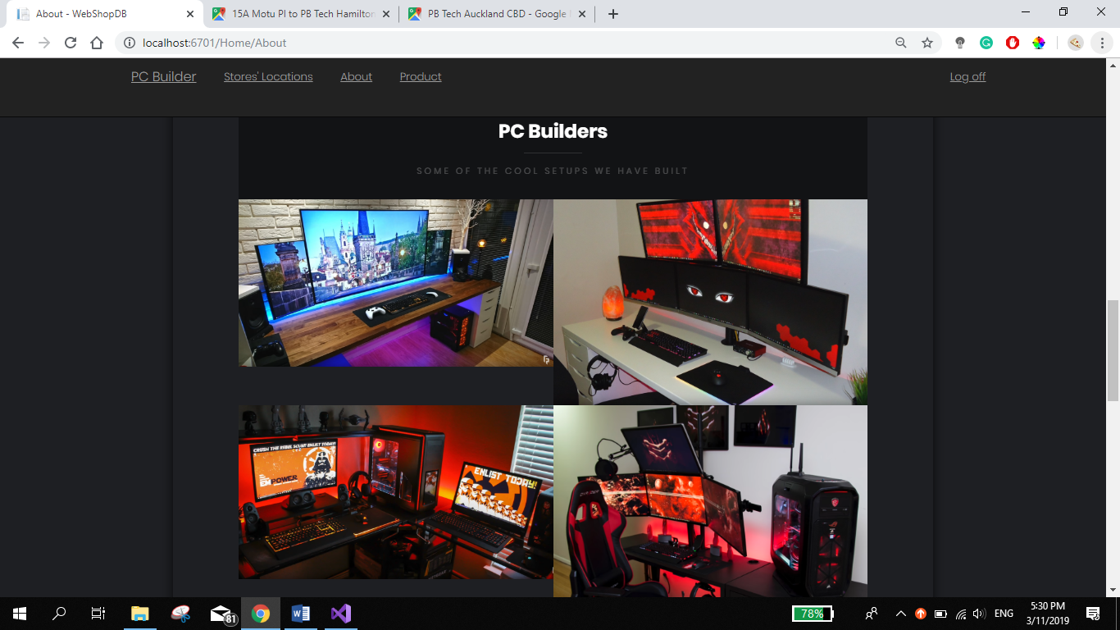

Fig.7. About us page2.

All the products listed in the database are shown in the products page with picture, name of the product, description, cost. As shown in the figure below.

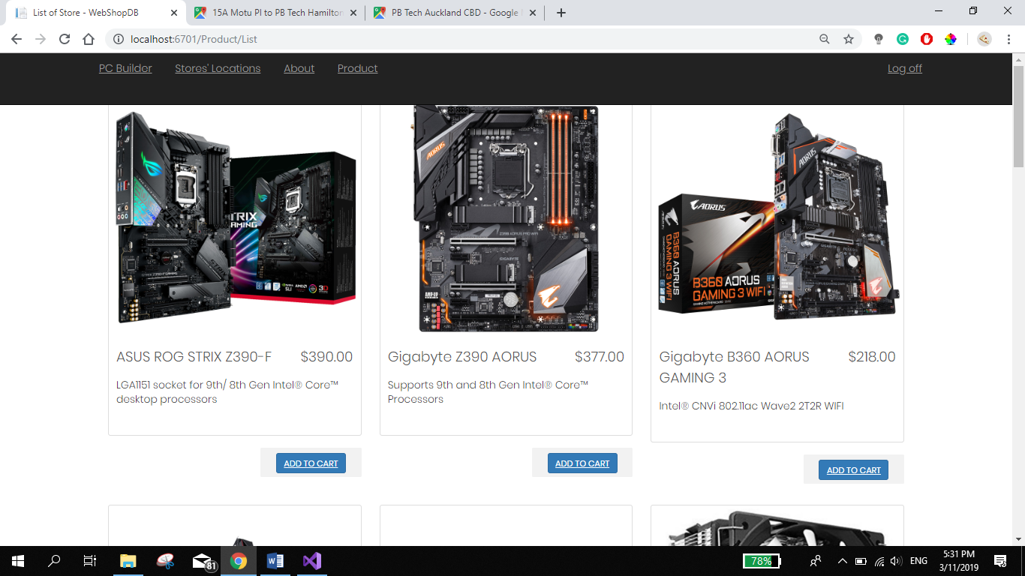

Fig.8. products page.

In the shopping cart page, the users can check out or purchase more products. This page shows the total cost of all the products purchased. The figure below shows the different products purchased and the total cost for the products purchased. Users can purchase the same product multiple times.

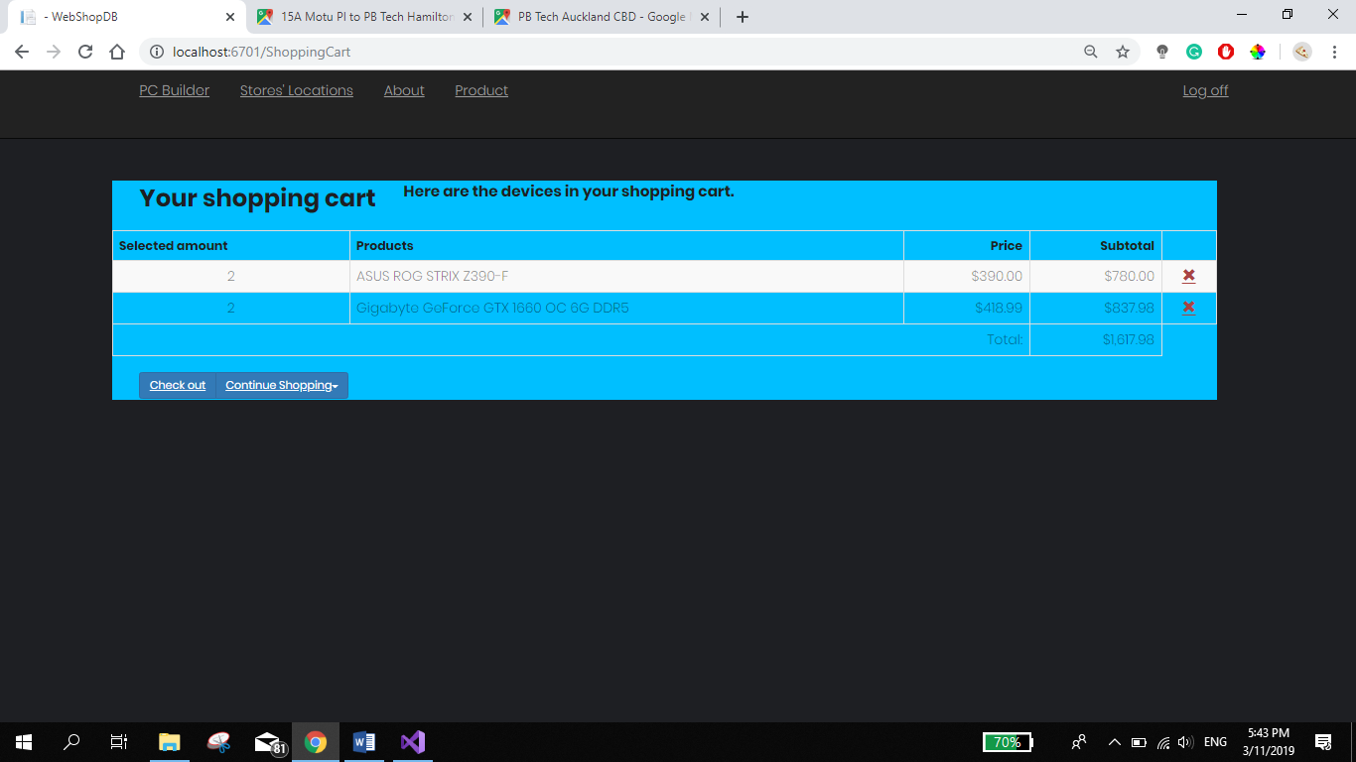

Fig.9. The shopping cart of the PC Builder.

Once the customer purchases the product by checking out; receive a confirmation page as shown below.

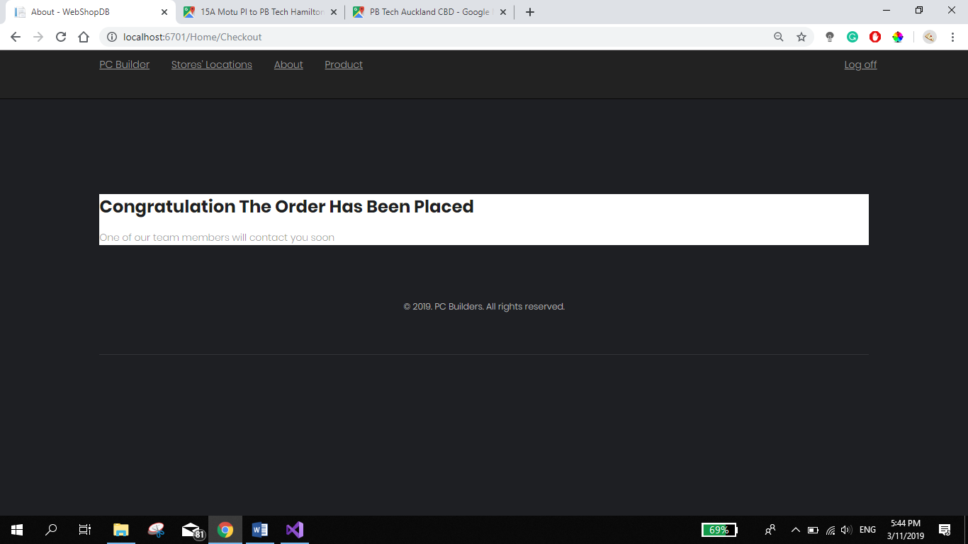

Fig.10. Confirmation page once the order is purchased.

# 4. Conclusion

In this report, the scope and out scope of the project is defined. The features and screenshot of the webpage are shown along with explanation. Fully functioning website will be shown on 4/11/2019 to the stakeholders.